# 1. Project Name:

**PO5_LED STRING ANIMATION**

# 2. Table History:

|  |  |  |  |
| --- | --- | --- | --- |
| **Author** | **Version** | **Date** | **Change Description** |
| Walid Adel | 1.0 | 23/1/2020 | Initial Creation |
| Youssef Kamal | 1.1 | 25/1/2020 | Changing Status section as mentioned in review sheet. |
| Walid Adel | 1.2 | 29/1/2020 | Added a Block diagram prototype, Microcontroller parametric and pins connections |
| Walid Adel | 1.3 | 4/2/2020 | Added requirement ID’s to the requirements, added list of tables, added PIN DIRECTION column to PINS Connection Table |
| Walid Adel | 1.4 | 7/2/2020 | Added some requirement ID’s, added Hardware Description sub header, added some modifications to the Block Diagram |
| Walid Adel | 1.5 | 8/2/2020 | Removed some Requirement’s ID’s, Changed The Requirements Structure and covered all Hardware Components in one header called Hardware Components, removed Microcontroller brief description Table. |

# 3. Document Status:

|  |  |  |  |
| --- | --- | --- | --- |
| **Author** | **Version** | **Date** | **Status** |
| **Walid Adel** | 1.5 | 8/2/2020 | Proposed |

# 4. Table of Content:

Contents

1. Project Name: 1

2. Table History: 1

3. Document Status: 1

4. Table of Content: 2

5. List of Tables 2

6. Requirements: 3

6.1 Block Diagram 3

6.2 Hardware Components 3

6.2.1 Microcontroller 3

6.2.2 LED 5

6.2.3 Switch 5

# 5. List of Tables

Microcontroller Parametric 3

PINS Connection 4

# 6. Requirements:

## 6.1 Block Diagram

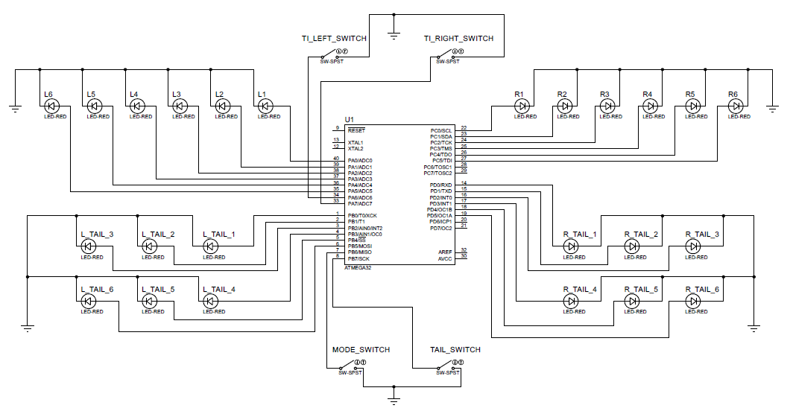

## 6.2 Hardware Components

### 6.2.1 Microcontroller

#### 6.2.1.1 Microcontroller Parametric:

|  |  |
| --- | --- |
| **Name** | **Value** |
| Program Memory Type | Flash |
| Program Memory Size (KB) | 32 |
| CPU Speed (MIPS/DMIPS) | 16 |
| SRAM (B) | 2048 |
| Data EEPROM/HEF (bytes) | 1024 |
| Digital Communication Peripherals | 1-UART, 1-SPI, 1-I2C |
| Capture/Compare/PWM Peripherals | 1 Input Capture, 1 CCP, 4PWM |
| Timers | 2 x 8-bit, 1 x 16-bit |
| Number of Comparators | 1 |
| Temperature Range (°C) | -40 to 85 |
| Operating Voltage Range (V) | 4.5 to 5.5V |
| Pin Count | 40 |

Req_PO5_LSAN_HSI_001_V01

#### 6.2.1.2 PINS Connection:

|  |  |  |  |
| --- | --- | --- | --- |
| **PIN NUMBER** | **PIN DESCRIPTION** | **PIN DIRECTION** | **CONNECTION** |
| 1 | PB0 | O/P | LED L_TAIL_1 |
| 2 | PB1 | O/P | LED L_TAIL_2 |
| 3 | PB2 | O/P | LED L_TAIL_3 |
| 4 | PB3 | O/P | LED L_TAIL_4 |
| 5 | PB4 | O/P | LED L_TAIL_5 |
| 6 | PB5 | O/P | LED L_TAIL_6 |
| 7 | PB6 | I/P | MODE_SWITCH |
| 8 | PB7 | I/P | TAIL_SWITCH |
| 9 | RESET | N/A | Not Used |
| 10 | VCC | N/A | +5V |
| 11 | GND | N/A | 0V |
| 12 | XTAL2 | N/A | Not Used |
| 13 | XTAL1 | N/A | Not Used |
| 14 | PD0 | O/P | R_TAIL_1 |
| 15 | PD1 | O/P | R_TAIL_2 |
| 16 | PD2 | O/P | R_TAIL_3 |
| 17 | PD3 | O/P | R_TAIL_4 |
| 18 | PD4 | O/P | R_TAIL_5 |
| 19 | PD5 | O/P | R_TAIL_6 |
| 20 | PD6 | O/P with initial value = 0 | Not Used |
| 21 | PD7 | O/P with initial value = 0 | Not Used |
| 22 | PC0 | O/P | LED R1 |
| 23 | PC1 | O/P | LED R2 |
| 24 | PC2 | O/P | LED R3 |
| 25 | PC3 | O/P | LED R4 |
| 26 | PC4 | O/P | LED R5 |
| 27 | PC5 | O/P | LED R6 |
| 28 | PC6 | O/P with initial value = 0 | Not Used |
| 29 | PC7 | O/P with initial value = 0 | Not Used |
| 30 | AVCC | N/A | Not Used |
| 31 | GND | N/A | 0V |
| 32 | AREF | N/A | Not Used |
| 33 | PA7 | I/P | TI_LEFT_SWITCH |
| 34 | PA6 | I/P | TI_RIGHT_SWITCH |
| 35 | PA5 | O/P | LED L6 |
| 36 | PA4 | O/P | LED L5 |
| 37 | PA3 | O/P | LED L4 |
| 38 | PA2 | O/P | LED L3 |
| 39 | PA1 | O/P | LED L2 |
| 40 | PA0 | O/P | LED L1 |

### 6.2.2 LED

#### 6.2.2.1 Features

* NTE3019 Light Emitting Diode (LED) Red Diffused, 5mm
* Tapered Barrel T−1 3/4 Package
* High Intensity Red light source with various lens colors and effects
* Versatile Mounting on PC Board or Panel
* T−1 3/4 with Stand−off

#### 6.2.2.2 Absolute Maximum Ratings

* Reverse Voltage, VR . . . . . . . . . . . . . . . . . . . . . . . . . . . . . . . . . . . . . . . . . . . . . . . . . . . . . . . . 5V
* Peak Forward Current (Note 1, IF . . . . . . . . . . . . . . . . . . . . . . . . . . . . . . . . . . . . . . . . . . . . . 1A
* Power Dissipation (TA = +25°C), PD . . . . . . . . . . . . . . . . . . . . . . . . . . . . . . . . . . . . . . . . . 180mW
* Derate linearly from 25°C . . . . . . . . . . . . . . . . . . . . . . . . . . . . . . . . . . . . . . . . . . . . . . . . . 2mW/°C
* Operating Temperature Range, Topr . . . . . . . . . . . . . . . . . . . . . . . . . . . . . . . . . . . . . . −55° to +100°C
* Storage Temperature Range, Tstg . . . . . . . . . . . . . . . . . . . . . . . . . . . . . . . . . . . . . . . . −55° to +100°C
* Lead Temperature (During Soldering, 1/16” (1.6mm) from case, 5sec max), TL . . . . +260°C

### 6.2.3 Switch

#### 6.2.3.1 Features

* 21000N series
* Plain bushing, with mounting plate
* Low profile toggle switches
* Same height for single and double pole
* Wave solderable only
* Low level or mechanical life: 100,000 cycles.
* Operating temperature: -40 °C to +85 °C (-40 °F to +185 °F)

#### 6.2.3.2 Electrical Specifications

* Max. Current/voltage rating with resistive load: Silver contacts (A): 4 A 30 VDC, Gold plated brass contacts (LD): 100 ma 30 VDC
* Minimum load: Silver contacts (A)- 100 ma 10 V, Gold plated brass contacts (LD)- 10 μa 5 VDC - 10 ma 50 mv
* Initial contact resistance: 20 mω max.
* Insulation resistance: 1,000 MΩ min. At 500 VDC
* Electrical life at full load: Silver contacts (A)- 20,000 cycles; Gold plated brass contacts (LD)- 50,000 cycles